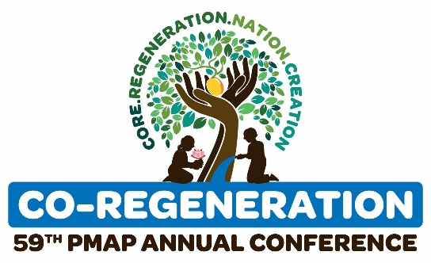

Dear

The PMAP Annual Conference is one of the largest national conferences for HR professionals, executives, people managers, and business leaders. It not only serves as an avenue for professional development and education but also provides a space for networking and building connections.

The PMAP Annual Conference is a 3-day virtual event that will happen on October 12-14, 2022, and I would like to request approval to attend.

I will be among hundreds of professionals to hear HR experts, innovators, people management, and business leaders discuss insights, trends, ideas, and approaches to business development, employee and labor relations, local and global HR, strategic people management, leadership development, and industry best practices. I believe this event will not only help my professional and personal development but will be an added value to our organization.

Below are the costs associated with the PMAP Annual Conference:

Registration Fee:
PMAP Member Early bird = P5,000
PMAP Non-Member Early bird = P7,000
Academe = P4,000
Chapter = P4,000
JPMAP = P2,000

I will apply my key takeaways from this event and will recommend actions to the team, and I will work to make sure we get the full value of this event.

Sincerely,

